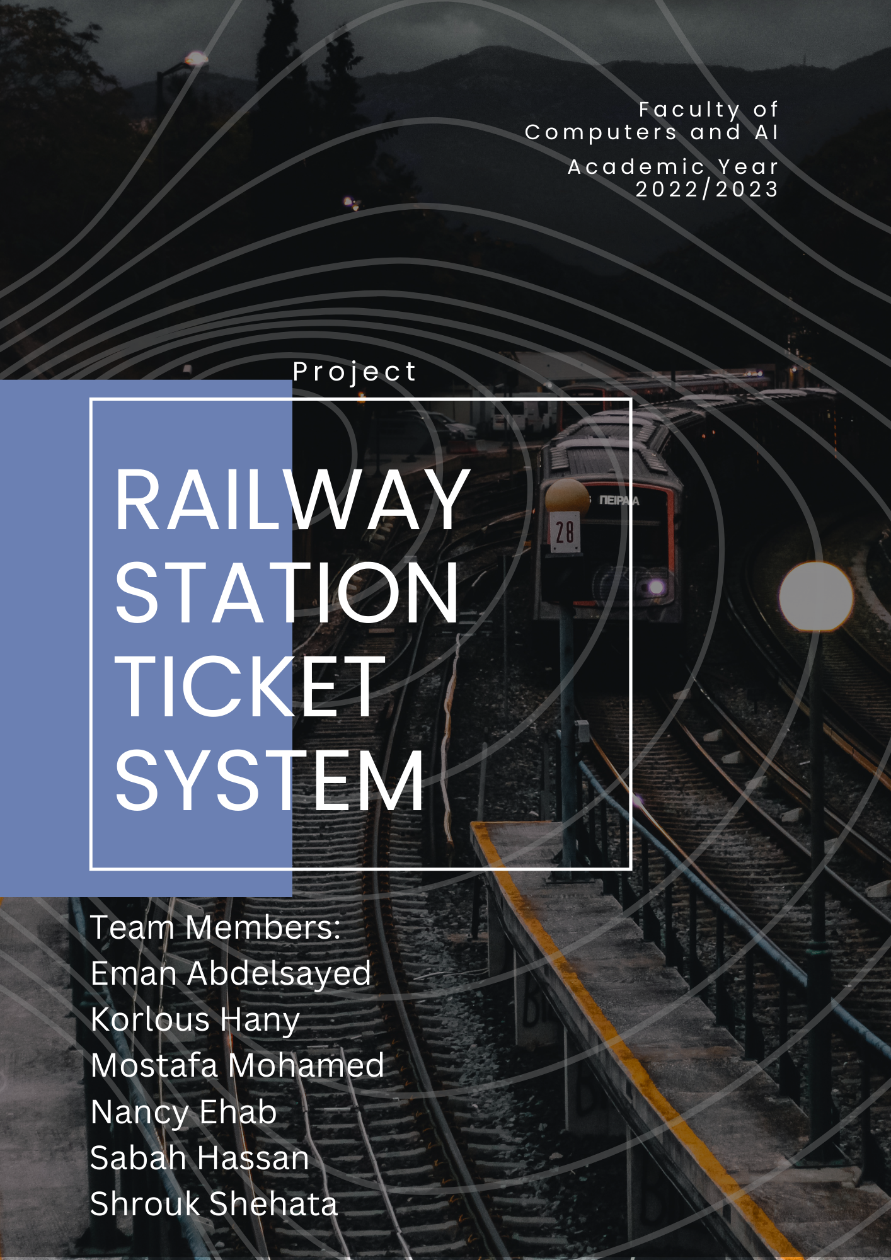++

***Contents***

**Introduction** 3

**1.Data Flow Diagram** 6

**2.Use Case Diagram** 9

**3.Activity Diagram** 13

**4.Sequence Diagram** 18

**5.Class Diagram** 22

**6.Front End** 23

**System Description Railway**

# **Introduction**

The railway reservation system facilitates the passengers to enquiry about the trains available based on source and destination, booking and cancellation of tickets, enquiry about the status of the booked ticket, etc. The aim of case study is to design and develop a data base maintaining records of different trains, train status and passengers. This project contains introduction to the railways reservation system. It is the computerized system of reserving the seats of train seats in advance. It is mainly used for a long route. Online reservation has made the process for the reservation of seats very much easier than ever before.

In our country Egypt, there are number of counters for the reservation of the seats and one can easily make reservations and get tickets. Railway reservation system, has described above, can lead to error free, secure, reliable, and fast management system. It can assist the user to concentrate on their other activities rather to concentrate on the record keeping. Thus it will help organization it better utilization of resources. Administrator of the project, with the help of a password, can enter new train record, display all train records, modify train records and delete train records. The record of train includes its number, name, source, destination, and days on which it is available, whereas record of train status includes dates for which tickets can be booked, total number of seats available, and number of seats already booked.

____________________________________________________________________________

**System Functions:**

*1.Login / Sign up.*

*2.View Timetable.*

*3.Booking.*

*4.Payment.*

*5.Tickets updates*

*6.Withdraw ticket.*

*7.Feedback*

**1.Login / Sign up:**

1.1User should choose whether to login or sign-up.

1.1.1User should fill credentials (Username, password, e-mail) in case of signing up.

1.1.2User should fill credentials (Username, password) in case of loging in.

**2.View Dashboard:**

2.1User should be able to preview whole schedule of the trains available to be booked in the station.

**3.Booking:**

3.1 User choose trip details (start point, destination, Time & date for trip, “return, open return”).

3.2 User select Tickets classification (class A,B,or C)

3.3 User should choose his car type (sleeping

cars, disabilities functioned cars).

3.4 User chooses number of tickets .

**4.Payment:**

4.1 User enters SSN ,E-mail, phone Number.

4.2 User chooses payment method ( fawry ,credit ).

**5.Tickets updates:**

5.1 User enters his /her ticket ID.

5.2 User manipulates his /her data.

**6.Withdraw ticket:**

6.1If user wants to cancel his/her reservation , user should enter ticket ID and he can refund money ( condition: 3 days before trip taking off)

**7.Feedback:**

7.1 User can rate our services performance for system improvement through sending feedback.

# **1.Data Flow Diagram**

**Context Diagram**

**Level 0 Data Flow Diagram**

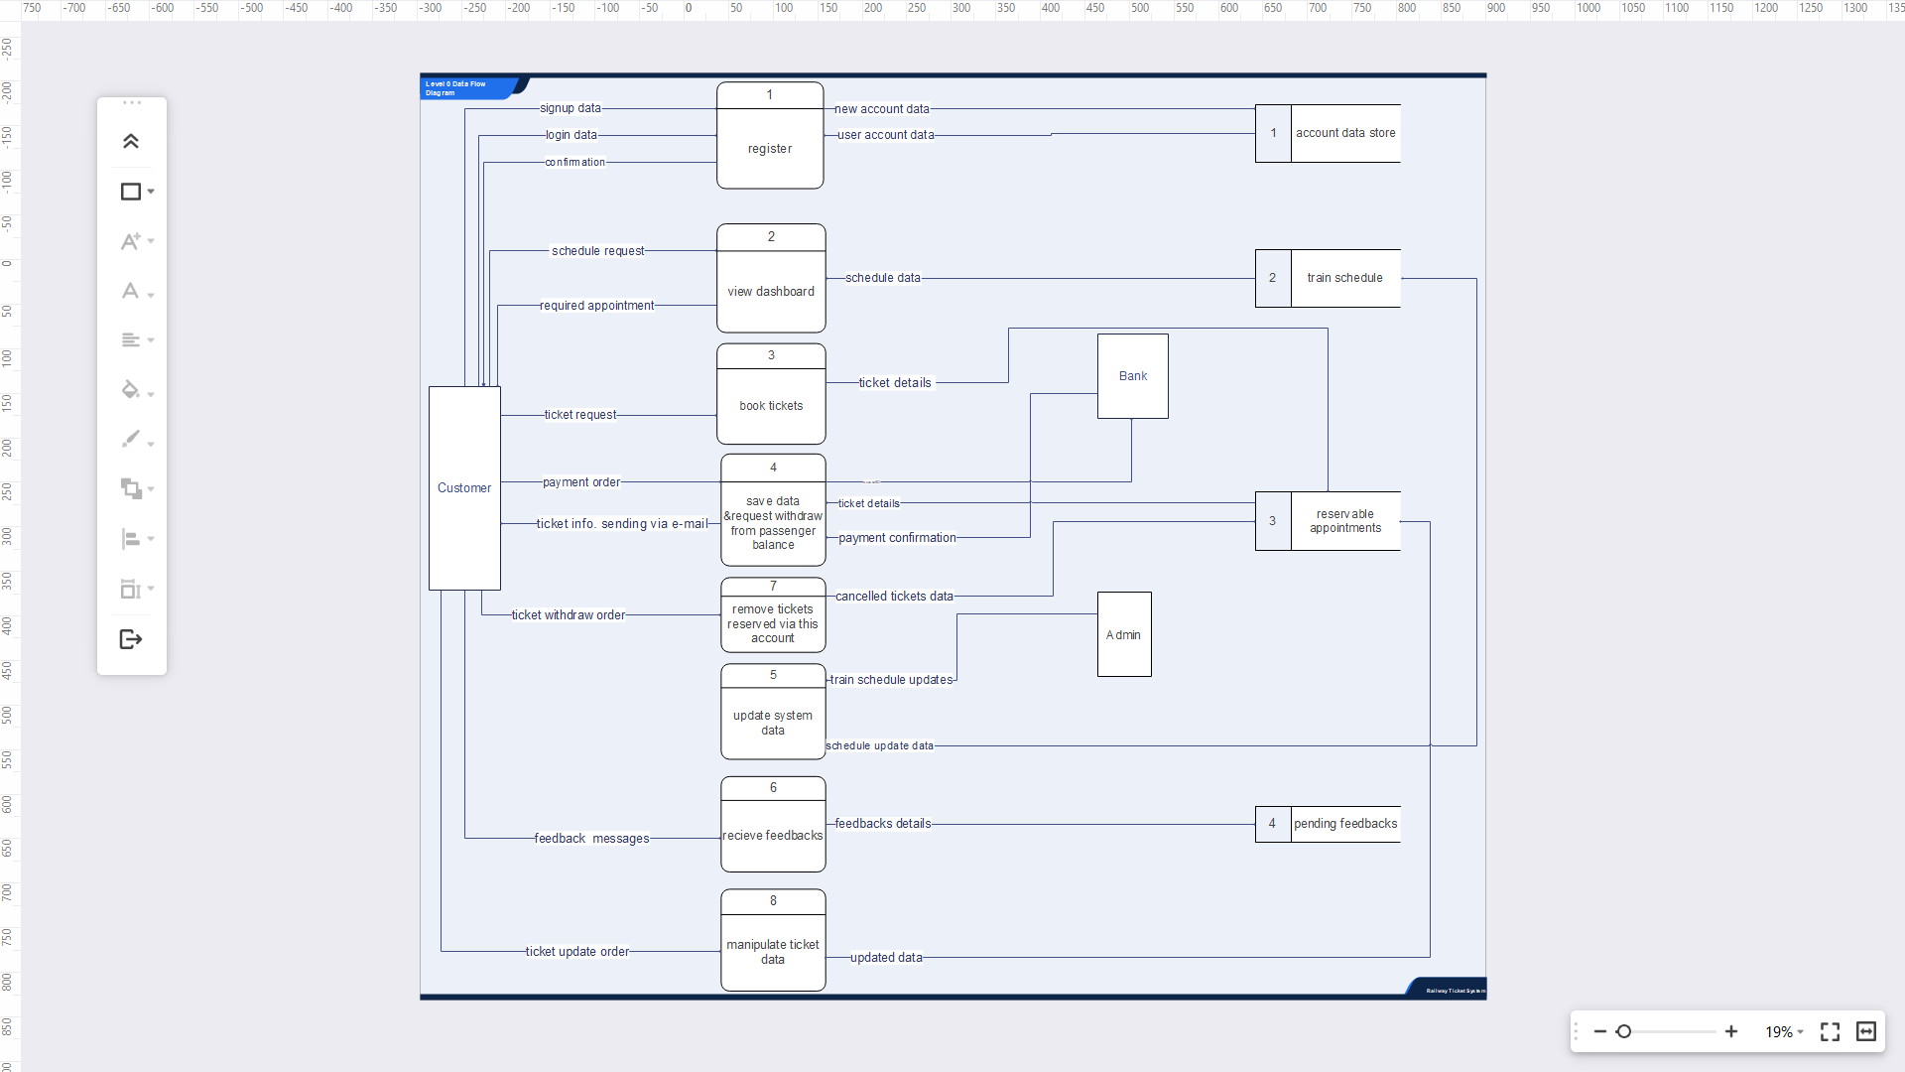

**Level 1 Data Flow Diagram**

# **2.Use Case Diagram**

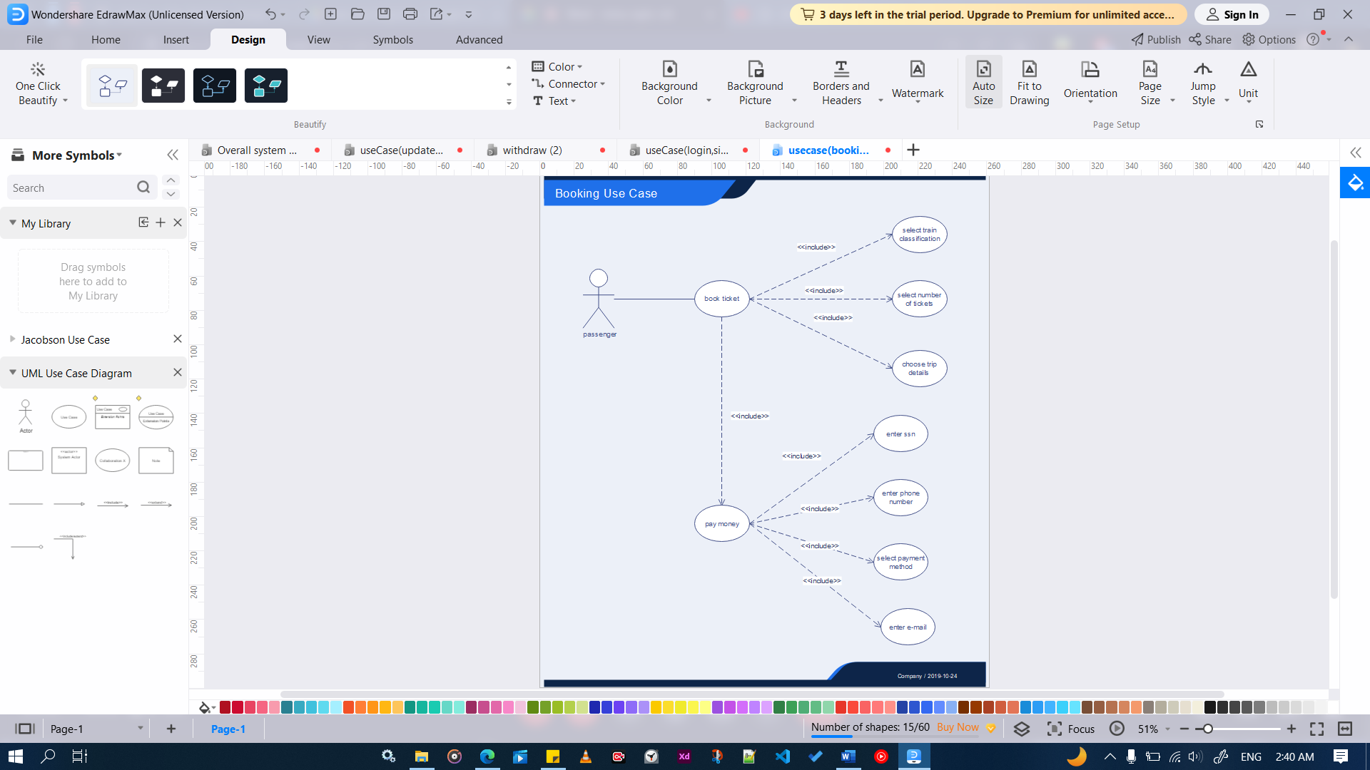

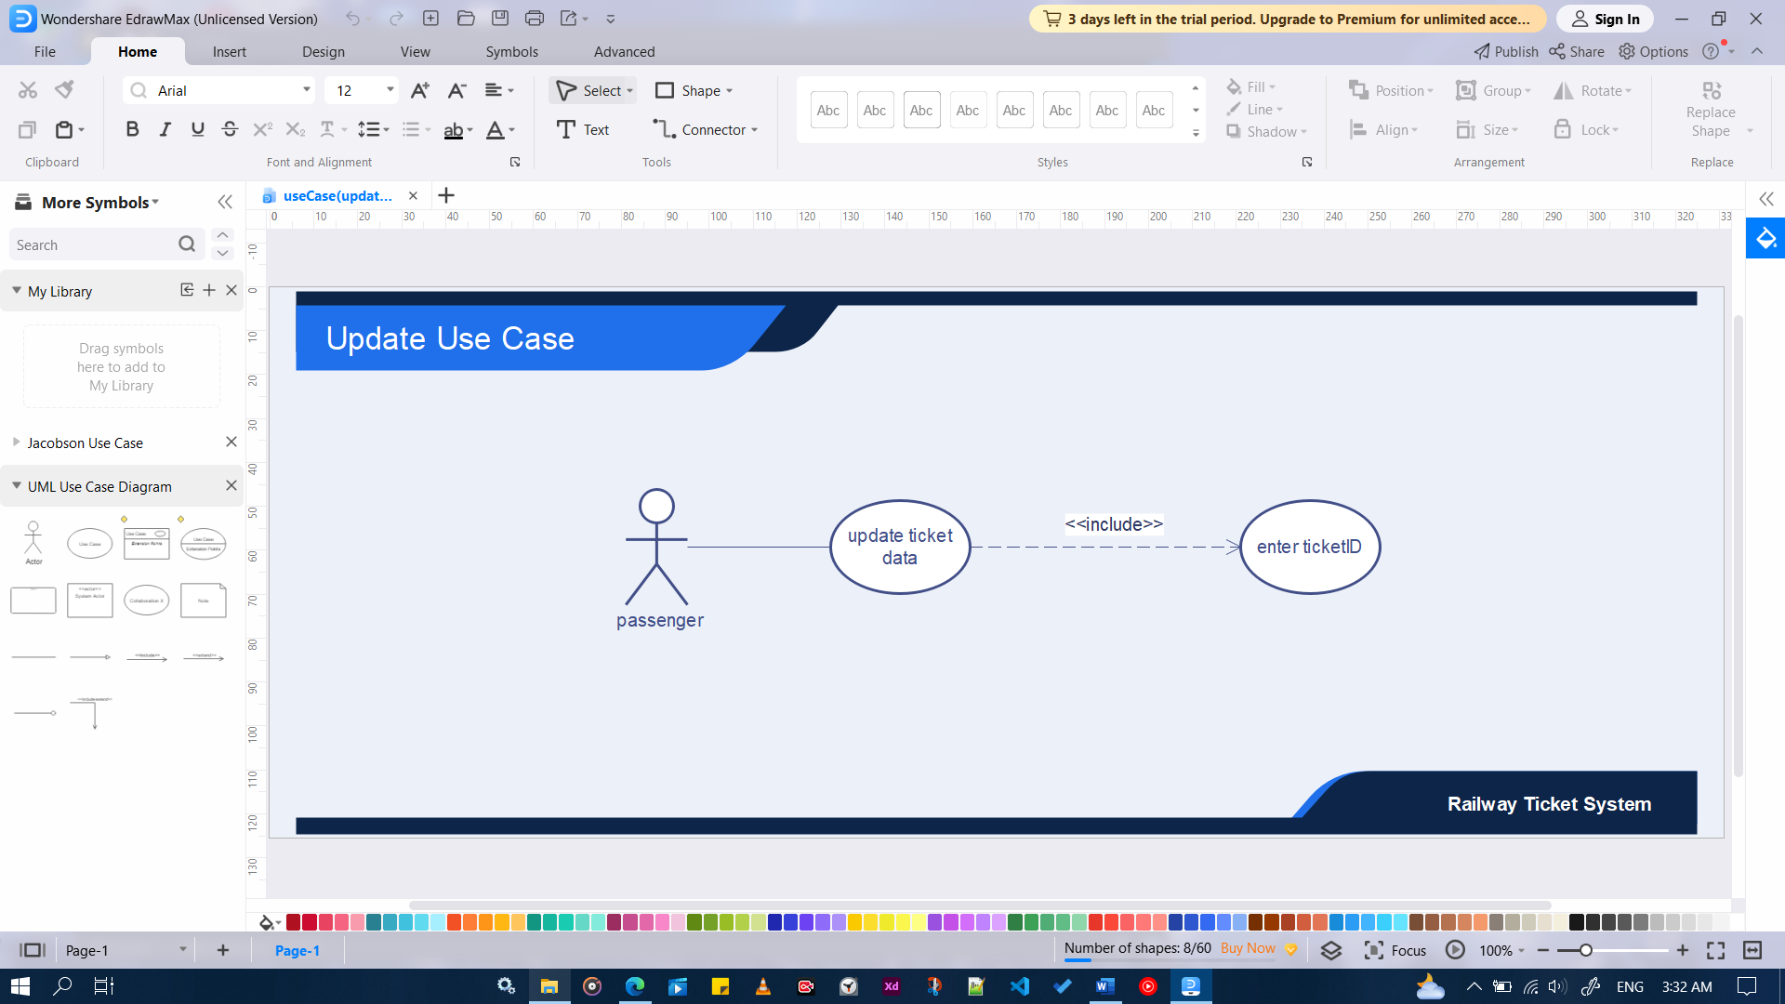

# **3.Activity Diagram**

# **4.Sequence Diagram**

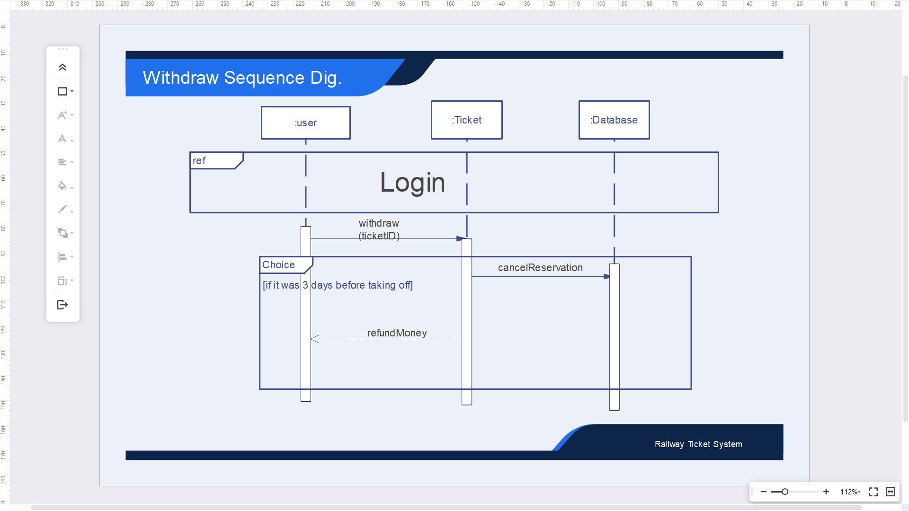

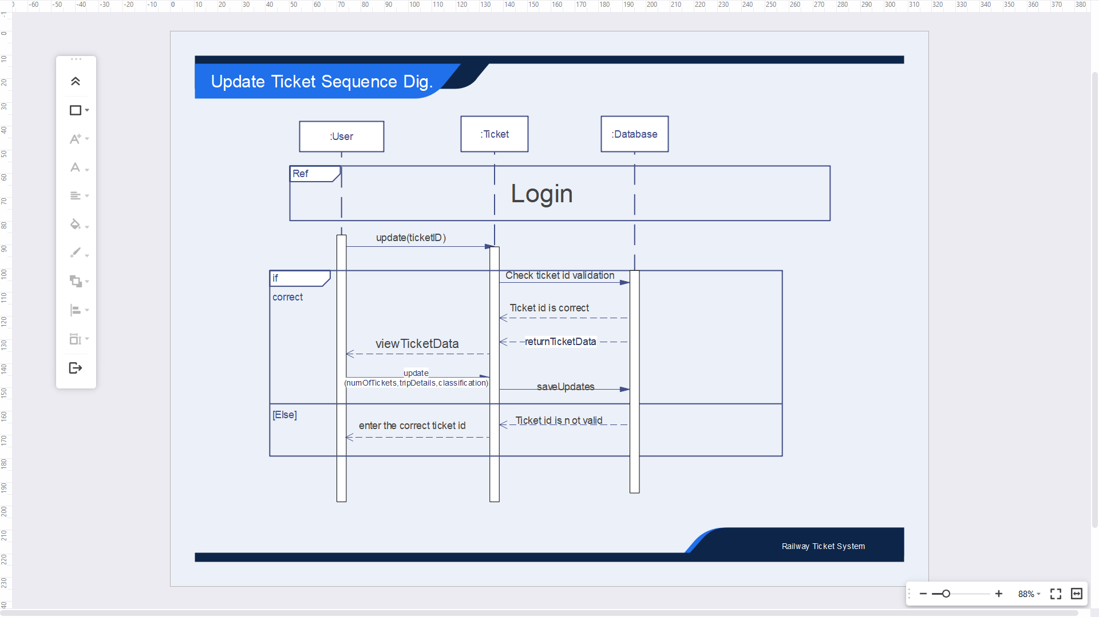

# **5.Class Diagram**

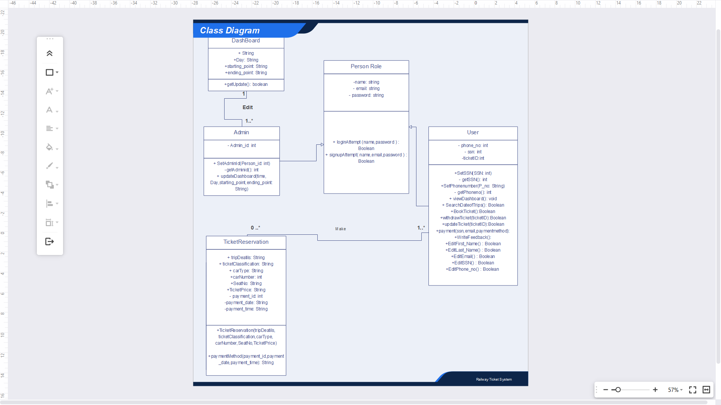

# **6.Front End**

Thank You!